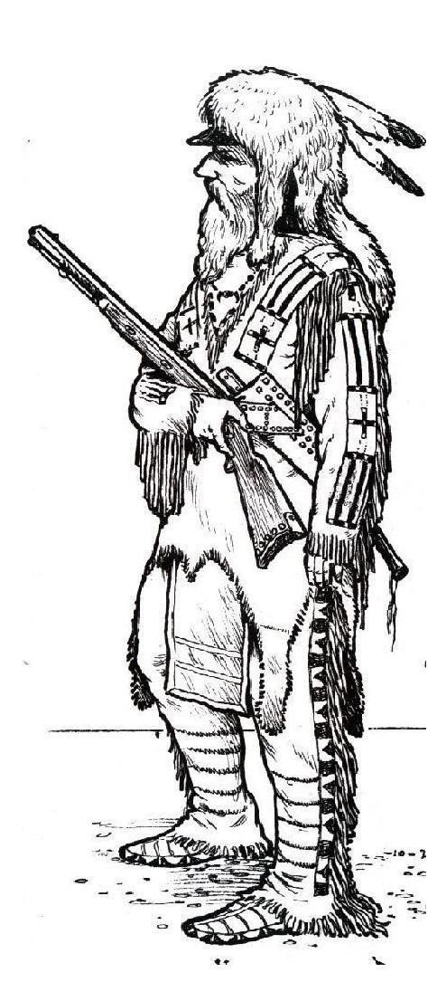
38th TEXAS FREE TRAPPERS RENDEZVOUS
SHINER, TEXAS – November 6-9, 2025

- Pre-1840’s rendezvous so only period tents and clothing in the main camp
area. Period dress is required for all competitors and campers.
- Period Camping – separate modern camping/no hookups. Bring water.
 Prospective and beginning buckskinners are welcome. Don’t be bashful if
your gear isn’t perfect yet. We can help you.
All shooting will be out of the pouch, using traditional weapons with open
open metal sights and patched round balls.

THURSDAY 11/6
Site access is available starting 1:00 PM for early camp and target setup.
Your help will be appreciated.

FRIDAY AND SATURDAY 11/7-8 (events run both days)
Rifle Walk Knife & Hawk Period Archery Match (No plastic or aluminum)

SATURDAY EVENING 11/8
- Council Fire Awards, News & Announcements, Music Potluck (bring something to share)

SUNDAY 11/9
Break camp and clean up the site before heading home.

WSCB Family Dues - $15/year. Competition fee incl. camping - $15. Camping only fee - $10/lodge. No additional fee for traders, but period or related items only. Each competitive event will have its own winners. Number of cash prizes will be based on numbers of competitors.

For more info contact:

Booshway Rusty (Matò) Hathaway, Rusty_Hathaway@msn.com, (512) 422-0377
or Segundo Jack (Straight Arrow) Simons, jblmrm3@satx.rr.com, (210) 846-6375
Facebook Group: Texas Free Trappers

Please RSVP to Jack that you will be attending. Entry into site is controlled and
you must call either Rusty or Jack upon arrival to open the gate.

Any threat of cancellation due to weather, call before leaving home!!
Bring a water bucket and brazier or fire containment ring in case a burn ban is in effect.

